Challenge: Red Miners

# Challenge Description :

**In the race for Vitalium on Mars, the villainous Board of Arodor resorted to desperate measures, needing funds for their mining attempts. They devised a botnet specifically crafted to mine cryptocurrency covertly. We stumbled upon a sample of Arodor's miner's installer on our server. Recognizing the gravity of the situation, we launched a thorough investigation. With you as its leader, you need to unravel the inner workings of the installation mechanism. The discovery served as a turning point, revealing the extent of Arodor's desperation. However, the battle for Vitalium continued, urging us to remain vigilant and adapt our cyber defenses to counter future threats.**

# Context :

## We are given a bash script that contains four base64 strings placed around, when decoded we are given a bunch of random strings, we then add the strings together to get the flag.

# Notes :

* Tools:
  + - Text editor - To open the bash script / downloaded files.
    - You can choose your way to decoding the base64 string for simplicity im going to use a website, “www.base64decode.org”

# Flag :

* Download the file and open it up. It is pretty obvious what the Base64 strings are in this file. The First 634 lines of the script is just junk. The first Base64 string we get is given in a url,

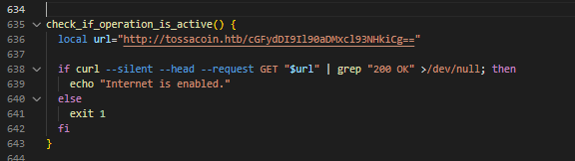

* When we decode the first string we get what seems to be the seconds part of the flag, as a hint.
* We then find two more base64 encoded strings going further down the scripts. We Will also Decode these.

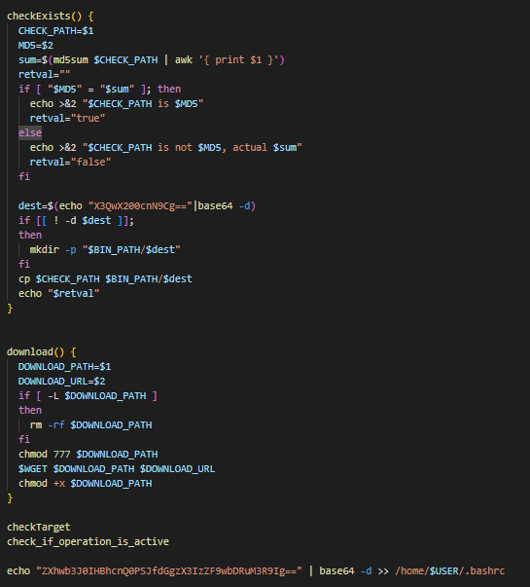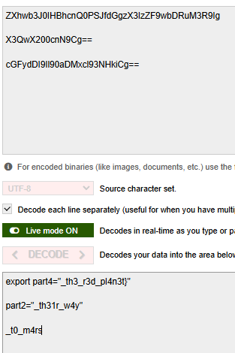

* So far it looks good, we just need to find one more part to finish the flag off. And of course it at the bottom of the script, decoding this we get.

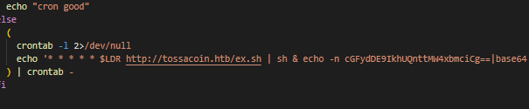



* Making the Flag: **HTB{m1n1ng_th31r_w4y_t0_m4rs_th3_r3d_pl4n3t}**